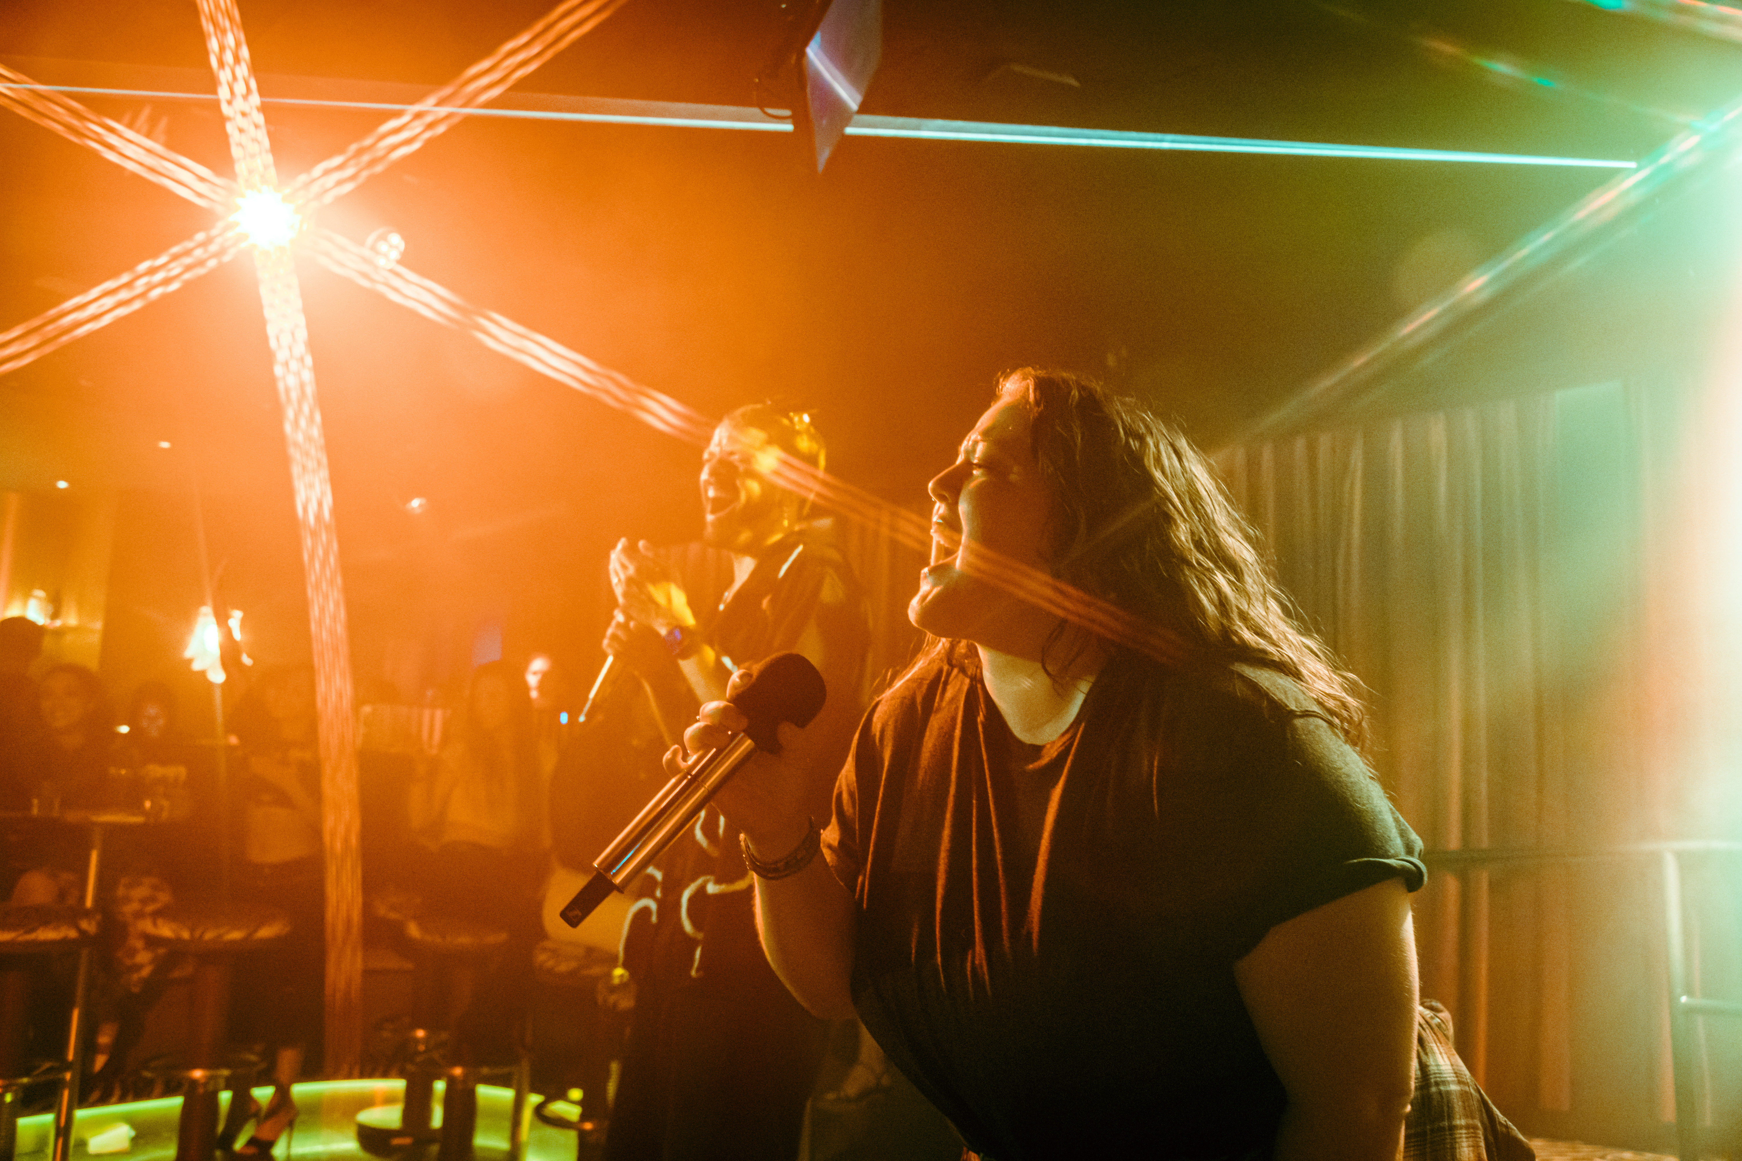
Mic Drop Raises the Bar for Karaoke Audio with Sennheiser Wireless Audio

Inside the Former Home of Larrabee Studios, the West Hollywood Venue Uses Sennheiser EW-DX to Deliver a High-Fidelity Karaoke Experience

WEST HOLLYWOOD, Calif., June 22, 2026 – The story of Mic Drop starts inside a landmark building — the former West Hollywood home of Larrabee Studios, the legendary recording space founded by Carole King and Gerry Goffin that hosted artists like Prince and Cher, helping define generations of popular music. For Mic Drop founders Leo and Oliver Kremer, a professional musician himself, that history was more than just trivia — it was a technical mandate. To bring their vision of a hip, modern karaoke bar into fruition, the Kremer brothers teamed up with the engineers at Pineapple Audio to create a technical backbone powered by the Sennheiser EW-DX digital wireless system.
"You can feel it in the bones of this building," Leo Kremer says. “The space harbors the magic of history. When we learned about the Larrabee connection, we knew we had to live up to that legacy of recording-studio sound." Having formerly acted as the bass player for Third Eye Blind, Kremer understood the value of high-quality audio and wanted to kill off the thin, distorted sound that usually defines a night of karaoke. He envisioned "Art Disco" — a vibe that’s equal parts 1920s glamour and 1970s glitz.
Making its home in the former location of Larrabee Studios, Mic Drop’s “art disco” sensibilities compliment the buildings historic legacy. Photo credit: Rob Stark/Mic Drop Karaoke.

The project was a massively intricate undertaking. With 30 wireless channels running at the same time across 13 private suites and a main stage, Matt Edgar of audio visual consultant Pineapple Audio noted that the main hurdle of integration was delivering acoustic separation while keeping that high-end studio feel across a 6,000-square-foot floor plan.
"We were intentional about preserving the building's integrity," Edgar explains. "Each room acts as its own controlled environment. Our goal was to minimize bleed between suites while maximizing clarity. We wanted guests to get the same performance they'd expect in a professional studio, no matter where they are in the venue." The EW-DX was the only piece of technology considered to properly bring the vision to life. The system features an ultra-low 1.9 ms latency, which is the difference between a singer feeling "in the pocket" or feeling a distracting delay in their monitors.
Sennheiser gear including the EW-DX, WSM, and wireless microphones help make karaoke at Mic Drop feel (and sound) like a professional production. Photo credit: Rob Stark/Mic Drop Karaoke.

Managing 30 channels in the middle of West Hollywood has the potential to become an RF nightmare. Edgar’s team handled this by utilizing Sennheiser’s Wireless Systems Manager (WSM) software to perform floor-by-floor environmental scans. By mapping the RF floor and using a centralized receiver setup, they assigned frequencies with surgical precision.

"The EW-DX system uses an equidistant frequency grid," says Edgar. "It makes coordination way simpler because it gives us consistent audio across every channel without intermodulation risks. We used Sennheiser Control Cockpit for the initial naming and network setup, but now we handle the ongoing management through remote monitoring." On the operational side, Mic Drop uses CHG 70N network-enabled chargers. When a group leaves a suite, the handhelds go right back into the docks to top off the BA 70 rechargeable batteries. This allows the staff to monitor battery health from the front desk, ensuring that no guest is ever interrupted by a dead battery.
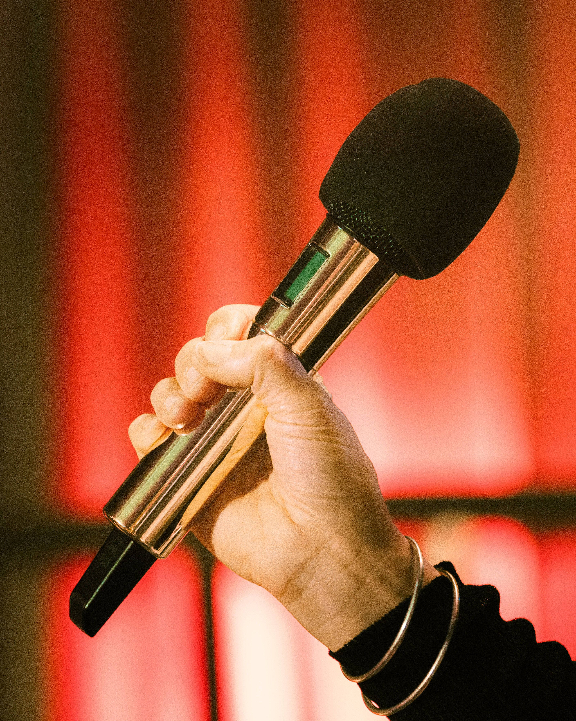
Guests can belt out their favorite songs using gold-plated Sennheiser mics, bringing the rock star experience to karaoke performers of all skill levels. Photo credit: Jessica Lee/Mic Drop Karaoke.

At Mic Drop, the gear is part of the art. The venue uses bespoke, gold-plated Sennheiser microphones that stand out against the burgundy and midnight blue walls. These aren't just for show; they’re the primary connection between the singer and the stage. "The microphone is the ultimate touchpoint," Oliver Kremer says. "You feel the weight. You feel the power the second you grab it. It changes how you perform."

That love for the hardware is even built into the ceiling. The room’s centerpiece is a functioning disco ball sculpted as a 30,000-tile replica of the Sennheiser e 835 mic dubbed the “Macrophone.” As Leo puts it, "We debated altering the design but ultimately decided that it had to be an exact replica. It’s eye catching, it's elevated, and it's super fun. That’s Mic Drop to a tee."
The Macrophone, a giant disco ball modeled after the e 835 mic, spins above the bar, keeping singers illuminated and reaffirming Mic Drop’s dedication to professional-grade audio. Photo credit: Rob Stark/Mic Drop Karaoke.

The result is a room where technical specs drive the fun. Whether it’s a pro singer or a first-timer, the sound stays crisp, even over the custom subwoofers built directly into the banquette seating. By choosing gear like the EW-DX, Mic Drop has turned karaoke into a studio-grade experience. When the lights hit that golden mic disco ball and the vocals are this clear, every guest feels like a headliner. It’s more than a night out — it’s a standing ovation waiting to happen.

(Ends.)
###

About Mic Drop Karaoke
Mic Drop Karaoke is an upscale karaoke and nightlife destination redefining the karaoke experience through premium sound, immersive lighting, elevated design, and hospitality-driven service. Founded by brothers and hospitality entrepreneurs Leo and Oliver Kremer, Mic Drop blends professional-grade audio and production with thoughtfully designed private rooms and a dynamic main stage – giving every guest the feeling of being a rockstar. Mic Drop sets a new standard for modern karaoke and experiential nightlife. For more information, follow @MicDropLA or visit https://www.micdrop.la/.

About the Sennheiser brand
We live and breathe audio. We are driven by the passion to create audio solutions that make a difference. Building the future of audio and bringing remarkable sound experiences to our customers – this is what the Sennheiser brand has represented for more than 75 years. While professional audio solutions such as microphones, meeting solutions, streaming technologies and monitoring systems are part of the business of Sennheiser electronic GmbH & Co. KG, the business with consumer devices such as headphones, soundbars and speech-enhanced hearables is operated by Sonova Holding AG under the license of Sennheiser.

www.sennheiser.com
www.sennheiser-hearing.com

Local Press Contacts:
Daniella Kohan
daniella.kohan@sennheiser.com
+1 (860) 227-2235

InGear
Chloe Hildeman
chloe@ingearpr.com
+1 425-466-2264

